**Art Document**

Colour Palette

Greens, Browns, Black, Blues, Yellows, White

|  |  |  |  |  |  |  |
| --- | --- | --- | --- | --- | --- | --- |
|  |  |  |  |  |  |  |
|  |  |  |  |  |  |  |
|  |  |  |  |  |  |  |

The colours chosen are greens for nature, black, brown and yellows for dawn effect and also soil, blue and white for water. This colour palette mostly applies to our environment.

Character

Art Style: Anime art style

We wanted to use the anime art style as we wanted to venture into the target market of anime lovers, and our goal was to give fresh new experience with this art style for games.

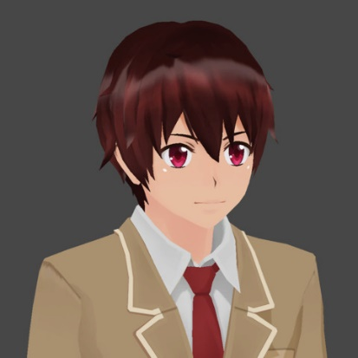

Environment

Theme: Magic Fantasy

Magical Forest with glowing magical creatures around the forest.

The forest is going to be based on where Erina is from, it is a magical forest of mages, and it is where they live in. Few elements in the forest are like glowing trees, glowing water, wooden structures, fireflies, glowing spirits and many more.

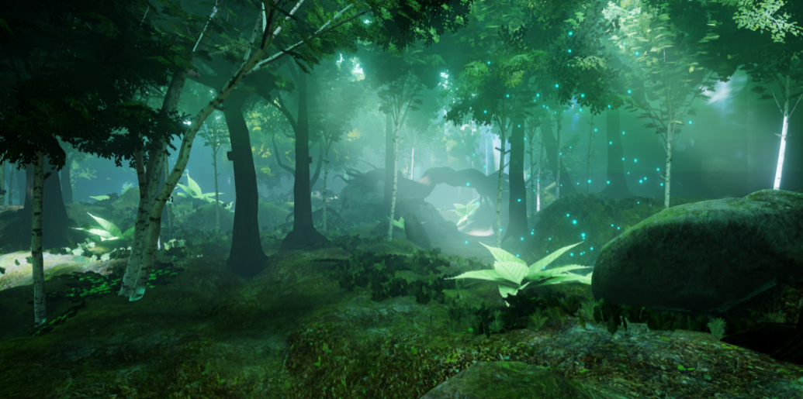

Reference of a magical forest.

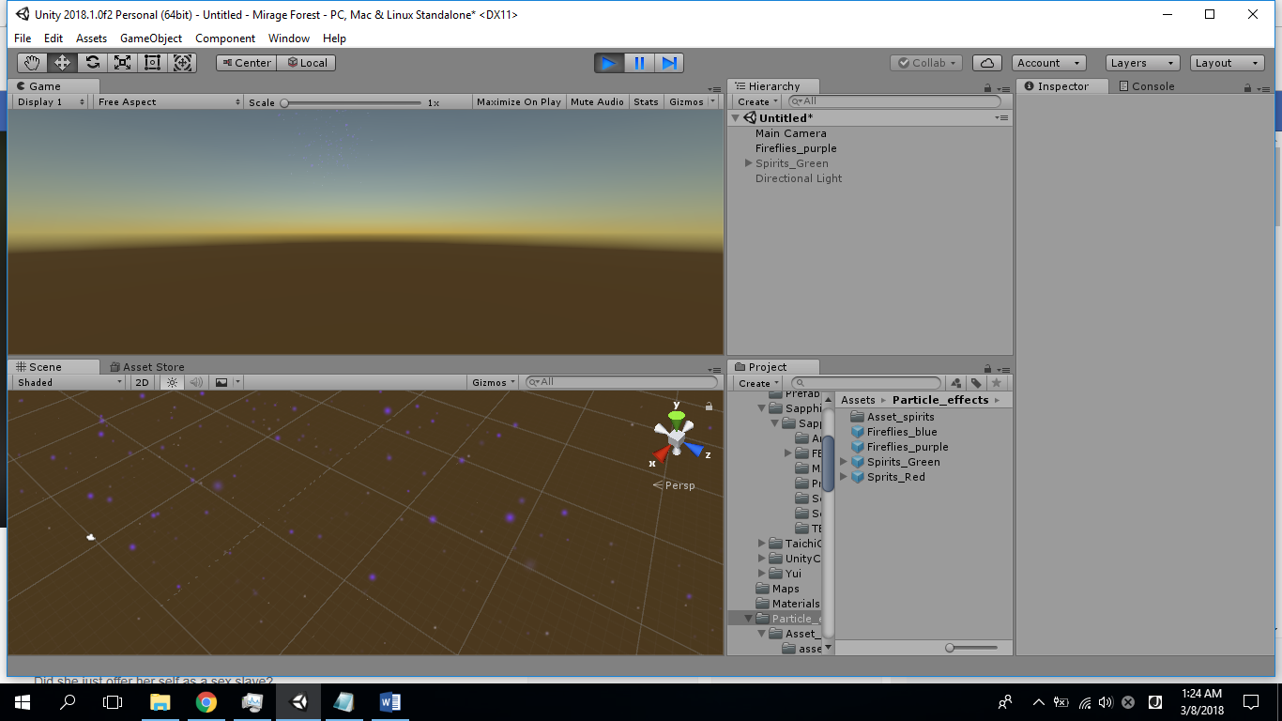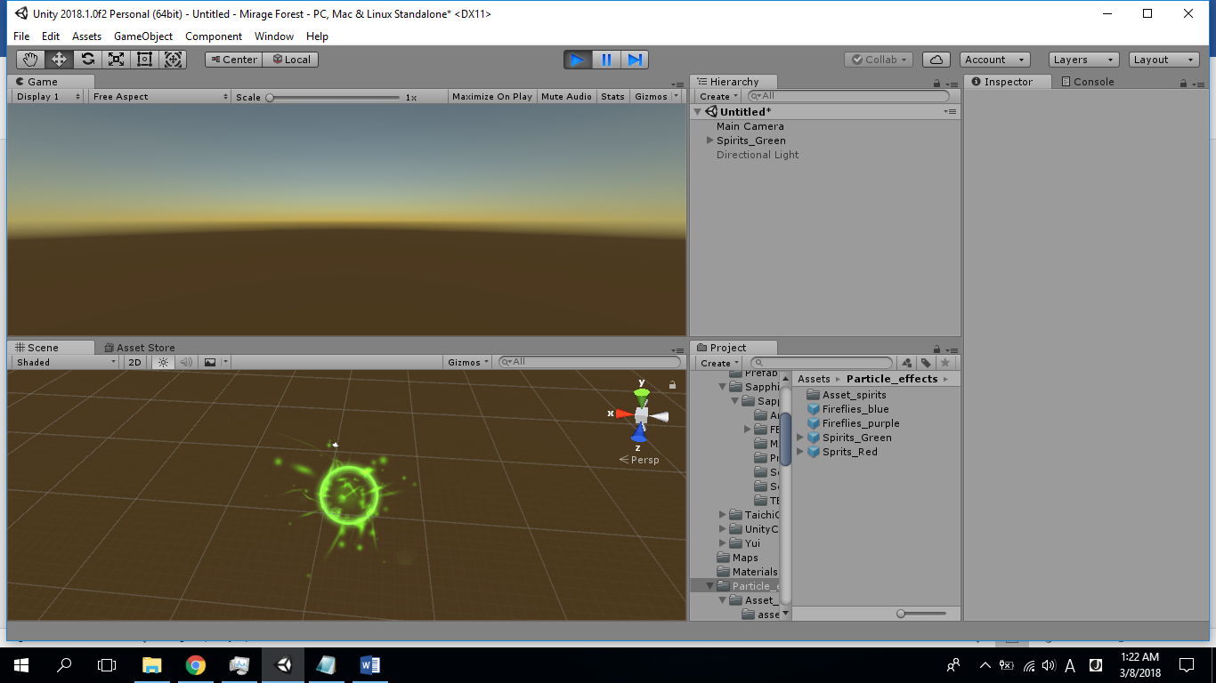

Glowing Spirit and fireflies made using particle effects by Lim Kheng Wei

Terrain Tiles: 3D Tillable Ground Blocks

The tiles are made to be tillable to create any kind of terrain paths.

Modelled by Thianchai Phromsuwan

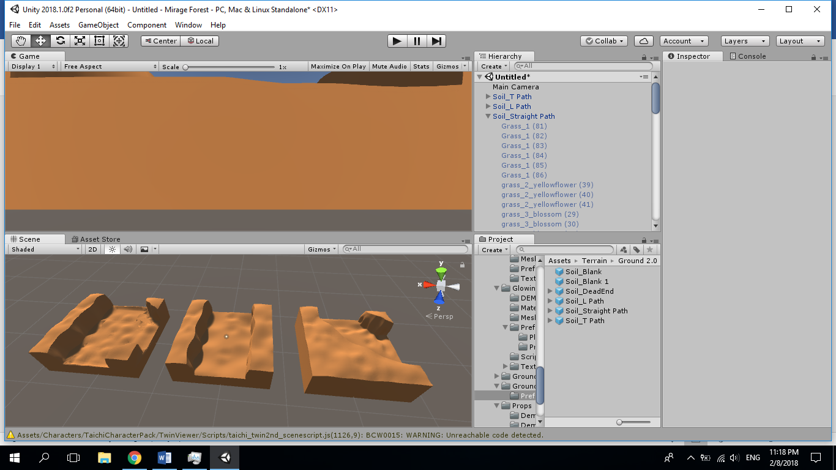

^ Some of the terrain tile modes as shown above

3rd party art sources

Characters:

Yamashita Kaizen (Taichi Hayami):

<https://assetstore.unity.com/packages/3d/characters/taichi-character-pack-15667>

Yamashita Mikasa (Unity chan):

<https://assetstore.unity.com/packages/3d/characters/unity-chan-model-18705>

Yamashita Hifumi (Yui, Sword Art Online, FanArt):

<https://sketchfab.com/models/b0c7d4d888bf4e99abc457f7e536e19a>

Erina (Amane Kisora-chan):

<https://assetstore.unity.com/packages/3d/characters/amane-kisora-chan-free-ver-70581>

Unrigged characters rigged and additional animations from:

<https://www.mixamo.com>

Terrain and Props:

<https://assetstore.unity.com/packages/3d/props/exterior/bench-75025>

<https://assetstore.unity.com/packages/3d/props/furniture/big-furniture-pack-7717>

<https://assetstore.unity.com/packages/3d/props/interior/props-for-the-classroom-5977>

<https://assetstore.unity.com/packages/3d/environments/fantasy-nature-57841>

<https://assetstore.unity.com/packages/3d/props/electronics/flatscreen-tv-9721>

<https://assetstore.unity.com/packages/3d/environments/fantasy/glowing-forest-79686>

<https://assetstore.unity.com/packages/3d/environments/landscapes/trp-ruin-pack-33397>

<https://assetstore.unity.com/packages/3d/props/electronics/tv-furniture-60122>